The purpose of this guide is to familiarize you with the process of using Carlile’s Client Service Portal.

# Accessing the Web Portal

1. Users can access the Carlile Client Service Portal (CSP) via the following link: [https://csp.carlile.biz](http://atwork-test.carlile.biz/)

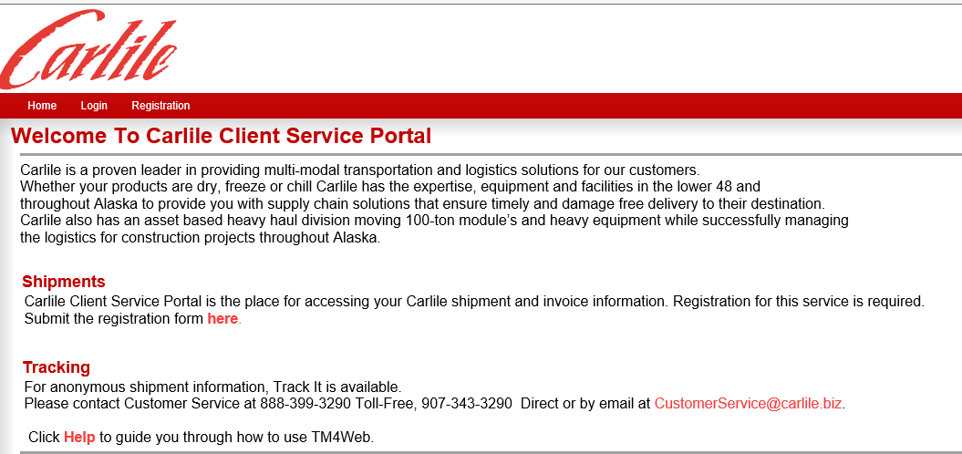

Figure : Welcome Page

# How to Gain Access to CSP web page

If you do not have a username and password to csp.carlile.biz web you will first need contact Customer Service to get an Access Code and then fill out the registration form found by clicking the Register link displayed on the Main Menu.

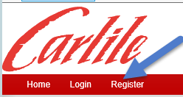

Figure 2: Register Link

* 1. You will soon receive an Access Code from Customer Service you will use to register.

1. Complete the **Registration Form**.

A red asterisk (*) indicates that an entry is required.

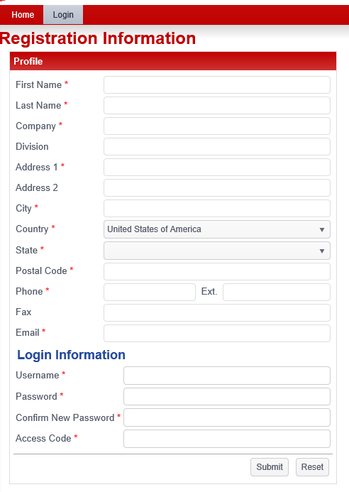

Figure 3: Register Page

1. The user login can be accessed by clicking **Login** tab in the main menu

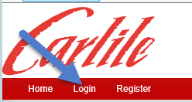

Figure 4: Login Link

* 1. Using the Login section, type in the **Username** and **Password** supplied to you by Carlile and then click the  button.

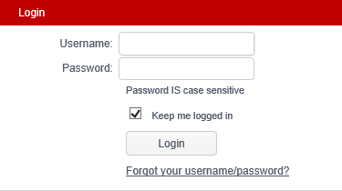

Figure 5: Login Window

* 1. This will display the **Home screen**

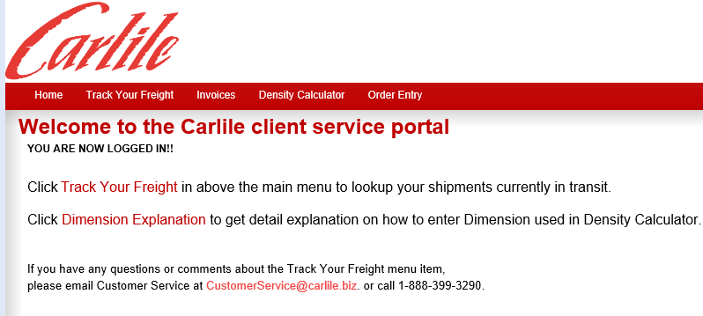

Figure 6: Login Welcome Page

* 1. There are multiple pages options that can be selected from the title bar.



Figure 7: Login Links

* + 1. Home – This displays the home screen.
    2. Track Your Freight* – This allows a user to view available loads and completed shipments.
    3. Invoices* – This allows a user visibility into Invoice summary and details.
    4. Density Calculator *– This allows a user the ability to determine the overall density of an order.
    5. Order Entry *– This enables a user the ability to enter details for pickup or shipment requests. Orders can be assigned a status prior to being converted into an order

*Covered in detail inside this documentation.

# Track Your Freight

1. The **Track Your Freight** pagedisplays **(**Trip Number, Bill Number, Bill of Lading, Probill#, Shipper, Consignee, Current Status, Pick Up By, Deliver By, Commodity, Pieces, Weight, Links) that will allow a user to search for shipments by multiple options/criteria:

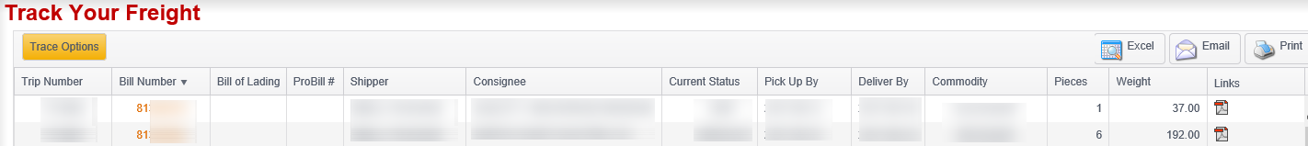Figure : Track Your Freight

* 1. **Search Options**
     1. Search By Field – click the  button to present a list of the following available fields to search by (Bill Number, Trace_No, ProBill#, PO#, Other, Quote#).
     2. Search Style Field– click the  button to select from either “Starts with” or “Exact”.
        1. Starts With – allows a user to enter a partial value. This will return all data that matches that value.
        2. Exact – allows a user to only search by the exact value entered.

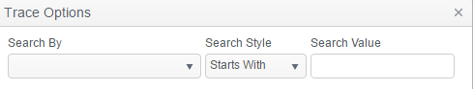

Figure 9: Trace Options Search Sections

* 1. **Advanced Search Options** will allow a user to select values appropriate to the search you selected limiting the Trace results.
     1. Show active -- This option limits Trace results to Active Freight Bills.
     2. Show active and completed -- This option limits Trace results to Active and Completed Freight Bills.
     3. Show all shipments -- Selected Trace results are returned as normal (all matching Freight Bill results will be displayed).
     4. Show my shipments only -- Results return only those Freight Bills that are attached to the current user (FBs entered by that user, or Freight Bills where the user appears on another Client's Notification List).
     5. Show my group’s shipments -- Trace results are limited to Freight Bills that are assigned to a Notification List and the Customer/Origin/Destination is within your Access Group.

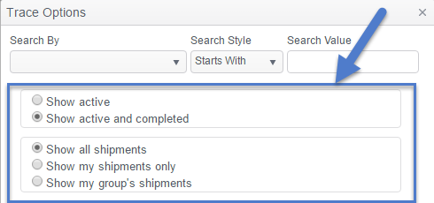

Figure 10: Trace Options Grouping

* 1. **Grid Sorting** will provide a user with the ability to sort the results of a search:
     1. Click on a column header title to sort the returned search data by that value. When you click any cell in the data range, the table is sorted in ascending order based on the column of the cell that is clicked, and you will see triangle facing up

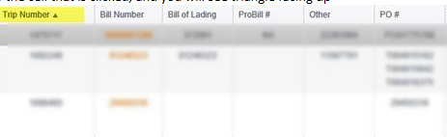

Figure 11: Grid Sorting

* + 1. When you double-click any cell in the data range, the table is sorted in descending order based on the column of the cell that is double-clicked and you will see triangle facing down

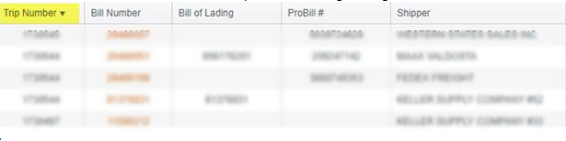

Figure : Descending Sorting

* + 1. When you triple-clicked any cell in the data range it will clear the sort on the column of the cell that is triple-clicked.

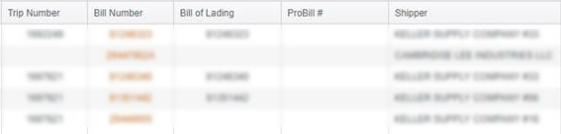

Figure : Clear Sorting

* + 1. If you have already sorted a different column it will sort the next column based on the pervious sorted column.

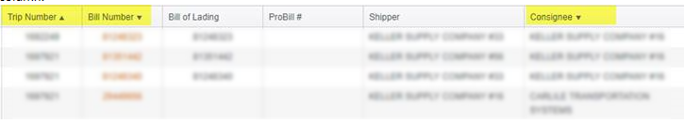

Figure : Previous Sorted colum

* 1. **Exporting Options** will allow a user to process the returned search in one of three ways:



Figure 15: Exporting Options

* + 1. ***Excel*** – This option sends the results grid to excel.
    2. ***Email*** – This option opens an email form in a new window allowing the user to send the results to the appropriate audience.
    3. ***Print*** – This option will allow the results to be sent to the user’s printer of choice.
  1. **Freight Information** if bill has been approved itwill allow a user to view invoice for a Freight Bill.
     1. To select bill invoice **Click** check box next to Trip Number,
     2. Then **Click Freight Information** PDF button located in top right side of window.

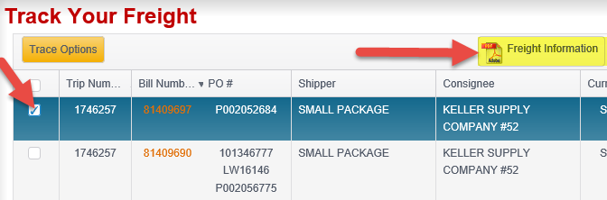

Figure 16: Freight Information

* + 1. **Report Viewer** if the bill has been approved it will display Invoice for that Freight Bill you selected.

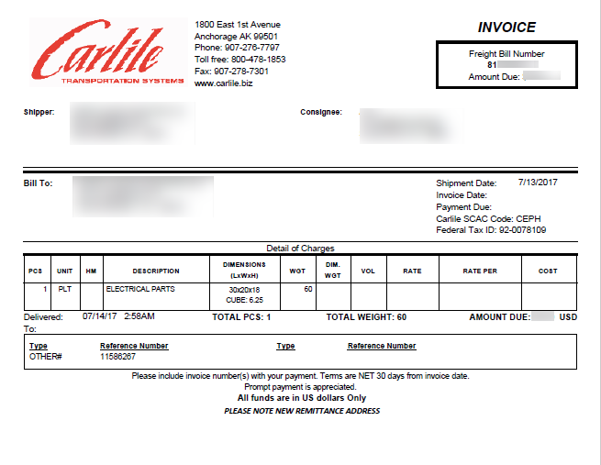

Figure 17: Example Invoice

* + 1. Hover over top of document to display Save or Print option for that Invoice

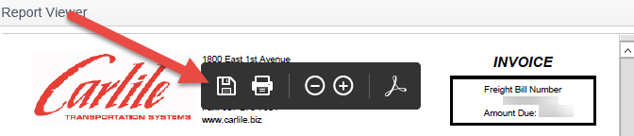

Figure 18: Invoice Save or Print

* + 1. At the bottom of the Invoice Click Email or Excel to view Invoice outside of CSP web page**.**



Figure 19: Invoice Click Email or Excel

* 1. **If Bill is not approved** 
     1. The Report Viewer will not display the Invoice it will state “**Invoice Pending**”.

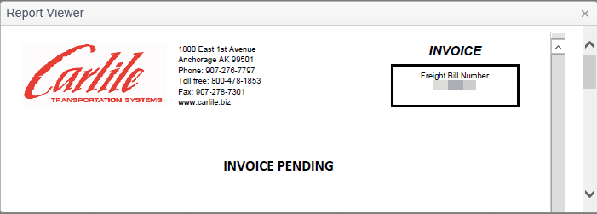

Figure : Invoice cannot display

* 1. **Bill Details** will allow a user the ability to review the current status of a movement. Click on any Bill Number (highlighted in orange) to present the following detail**:**

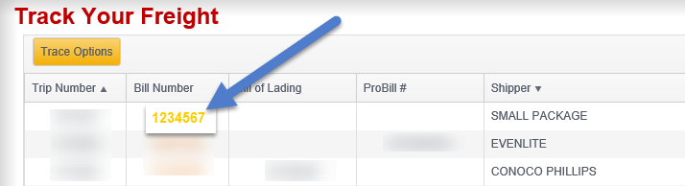

Figure 21: Bill Number Link

* + 1. ***Bill Header*** – Displays the ”Caller”, “Shipper” and “Consignee” address information.

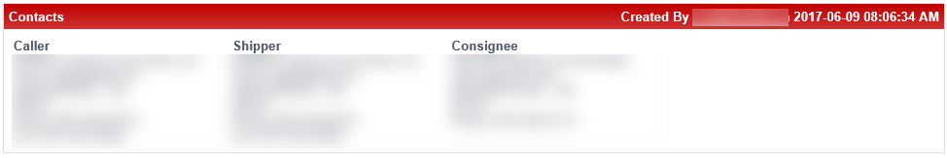

Figure 22: Bill Header

* + 1. ***Summary Info*** – Displays the “Current”, “Scheduled Pickup” and “Scheduled Delivery” information.

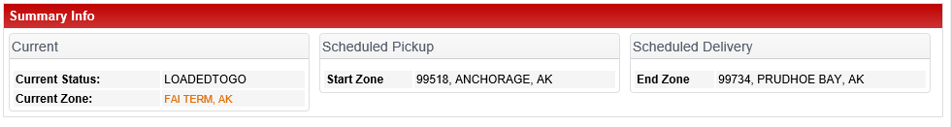

Figure 23: Summary Info

* + 1. ***Status History*** – Displays the “Manifest”, “Origin”, “Destination”, “Status”, “Trailer”, and “Date” as the freight moves from pickup to delivery.

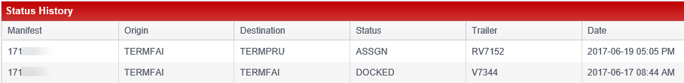

Figure 24: Status History

* + - 1. Status code description

|  |  |  |
| --- | --- | --- |
| APPROCONS | Approaching Consignee | |
| ARRCONS | Arrive Consignee | |
| ARRDOCK | Arrive At Dock | |
| ARRIVE | Arrive |  |
| ARRSHIP | Arrive At A Shipper | |
| ASSGN | Assigned | |
| COMPLETE | The Trip Is Done | |
| DEPCONS | Depart Consignee | |
| DEPSHIP | Depart Shipper | |
| DEPTERM | Depart From Terminal | |
| DISP | Dispatched | |
| DOCKED | Docked |  |
| ENROUTE | En Route | |
| ENTRY | Do Not Use | |
| LOADEDTOGO | Trailer Now Loaded To Go | |
| LOADING | Trailer Is Being Loaded | |
| PICKD | Picked Up | |

* + 1. ***Trace Numbers*** – Displays the “Type” (i.e. PO Number) and “Number” (i.e. 1234567890) of all trace numbers.

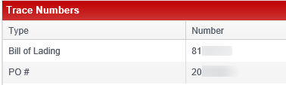

Figure 25: Trace Numbers

* + 1. ***Freight Details*** – Displays the “Pieces”, “Description”, “Commodity”, “Pallets”, and “Weight”



Figure 26: Freight Details

* + 1. ***Related Documents*** – Displays the images for any scanned documents (i.e. BOL). If the message “No Documents” is displayed, no documents have been scanned yet. It is recommended to check back at a later time for any updates.
       1. –Not Available at this time

1. The **Invoices** page displays Invoices with open balances and accounts receivable aging information for the Clients that have been added to the same Access Group as the current User.
   1. **Customers Grid** 
      1. ***Account Balance*** –displays Date, Customer ID, Customer Name, Address, and Balance list of account balances by customer ID.

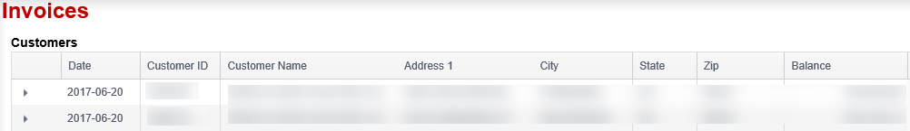

Figure 27: Account Balance

* + 1. ***Invoice Balance*** will allow a user the ability to view the Freight bills associated with Account Balance. Click on  button next to Date column to present the following detail: FB Number, Original Amount, Balance, Aged Days, Payment Date, and Reference

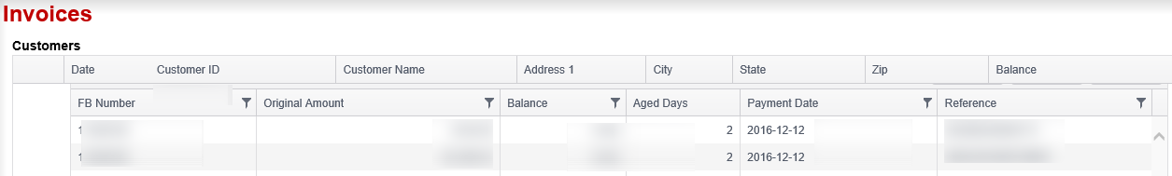

Figure 28: Invoice Balance

# Density Calculator

1. **Density Calculator** Page allows you to calculate the shipment density to properly describe goods on a bill of lading and to determine freight rates using a Density Calculator instead of manually manipulating record fields.
   1. In the Details section, add relevant commodity information, Length Width, Height, Weight, and # of Pallets, and click Calculate Density. The totals are calculated.

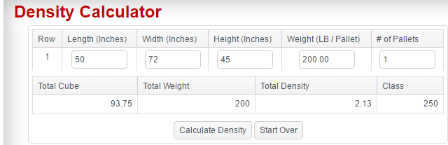

Figure 29: Density Calculator

# Order Entry

1. **Order Entry** Page allows you to request a pickup online, 24 hours a day. You can enter request pickup details like the delivery time needed; the exact type and quantity of freight and temperature requirements of the freight. The information entered is then available for Carlile Customer Service to accept directly into TruckMate and notifications can be sent to you.
   1. Click Add Order button

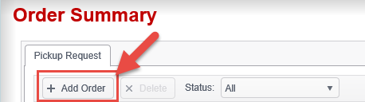

Figure 30: Add Order

The Order Entry page opens.

* 1. The **Header** section displays a number of high-level Freight-Bill related fields, such as the Freight Bill number (if applicable), Site ID, Service Level, etc.

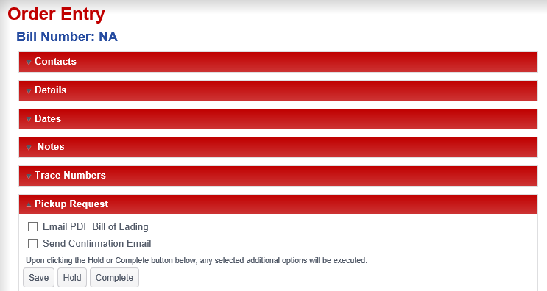

Figure 31: Order Entry

* 1. In the **Contacts** section, modify relevant information for the order. For additional information on the contact section (missing a sentence?)

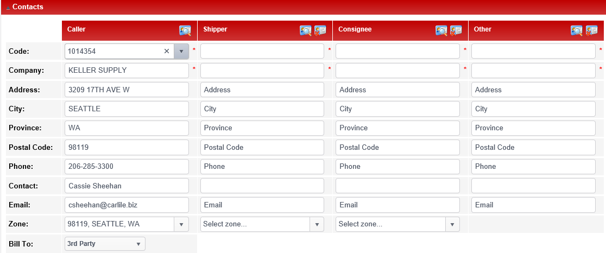

Figure 32: Order Entry 🡪 Contacts

* 1. In the **Details** section, modify relevant commodity information for the order.

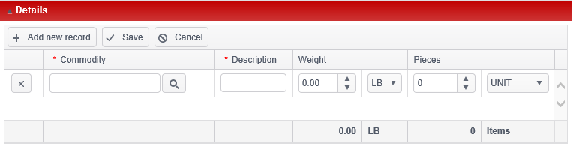

Figure 33: Order Entry🡪 Details

* 1. In the **Dates** section, select relevant dates for Pickup and Delivery times.

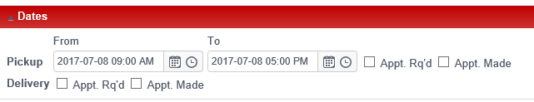

Figure 34: Order Entry🡪 Dates

* 1. In the **Notes** section, enter relevant notes regarding the order.

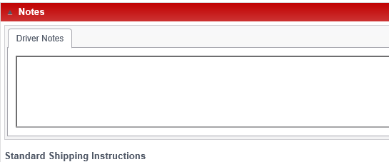

Figure 35: Order Entry🡪 Notes

* 1. In the **Trace Numbers** section, select the applicable Trace Type.

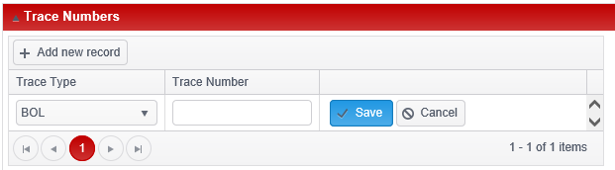

Figure 36: Order Entry🡪 Trace Numbers

* 1. In the **Pickup Request** section, select applicable options.

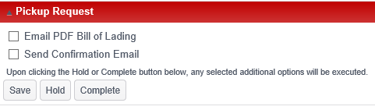

Figure 37: Order Entry🡪 Pickup Request

# Logout of csp.carlile.biz

1. Click the person drop down icon located on the right hand side of the window.

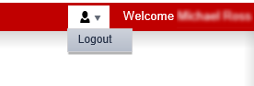

Figure : Logout